Application Form
Global Opportunities
Universidad de los Andes

Go Leadership
“Leadership in a Chilean and Latin-American context”
January 4th – 27th, 2017 | Santiago, Chile

Personal Information:

First Name
Last Name
Permanent Address
City |  |  |  | Zip Code
Country
Telephone
E-mail
Gender
Date of Birth (dd/mm/yy):
Nationality |  |  |  |  |  | Passport Nº
Issue Date  (yy/mm/dd) |  |  |  |  |  | Expire Date (yy/mm/dd)

In case of emergency, please contact:

First Name
Last Name
Address
City
Country
Telephone Include area codes
E-mail

Academic Information

Home University
School
Year
City /State

Country

Program name at UANDES | GO ANDES 2017
Start Date of the Program | (From) (04/01/2017)
Indicate End Date of the Program  *Select only one. | Hasta (Up to) ____ (13/01/2017)  ____ (20/01/2017)  ____ (27/01/2017)

Language Skills

Your native language is: ___________________

If you are not a Spanish native speaker, please complete:

Spanish
____  None | ____  Basic | ____  Intermediate | ____  Advanced

Medical Information

Please indicate if you suffer from any disease that requires constant medical attention during your stay in Chile.

It is a mandatory requirement for students to have a Medical Insurance with international coverage during their visiting term(s) in Chile.

I confirm that all the information provided in this application form is accurate and can be used by Universidad de los Andes strictly for the exchange program procedures.

_____________________________
Student’s signature

________ /________/________
Date

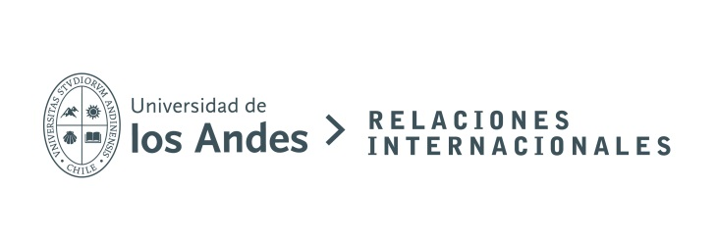

CHECKLIST

Please be sure to send us the following documents:

- Passport photocopy
- 1 ID size photograph (scanned)
- Requirement for invitation letter if you need a tourist visa to enter Chile

Application forms can be submitted until October 30th, 2016.

Please send all the information scanned in a PDF document to:

fgibson@uandes.cl

