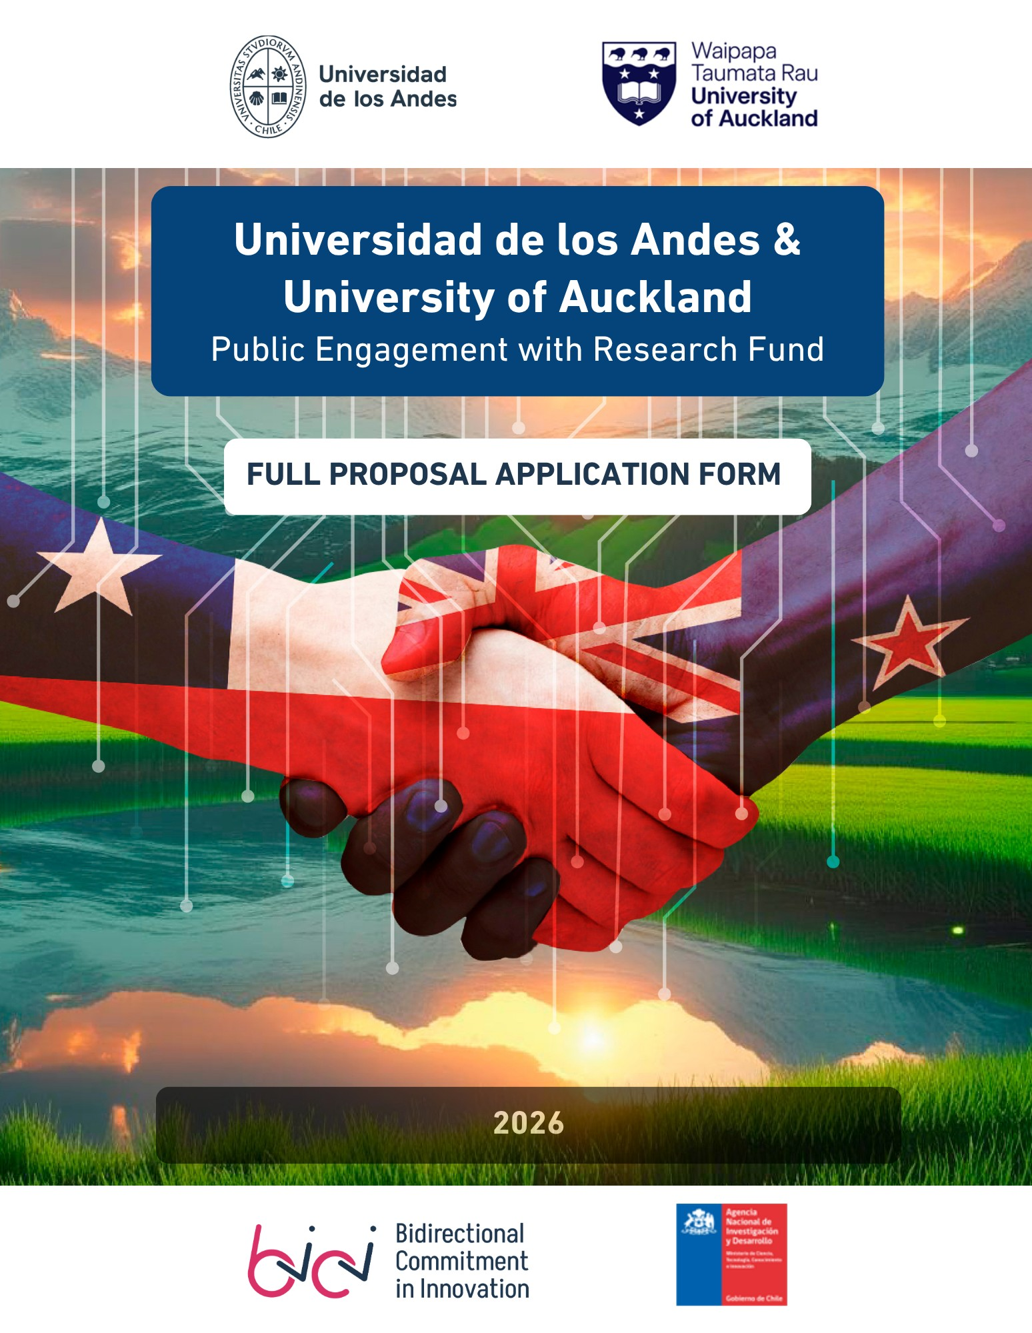
+

FULL PROPOSAL APPLICATION FORM
Universidad de los Andes & University of Auckland
Public Engagement with Research Fund
[This form must be filled out in English]
PROJECT IDENTIFICATION
Project title: maximum 25 words
Keywords: 3 to 5

I.- PROJECT TEAM
1.1. PROJECT DIRECTOR
Institution: |  | University of Auckland ☐ |  |  | Universidad de los Andes ☐
Full Name:
Faculty/Research Centre:
Telephone number:
Institutional mail:
Are you an Early Career Researcher? (No more than 8 years post-PhD or equivalent): YES☐ NO ☐
Weekly hours of commitment (minimum 4):
Academic background and experience in the project's fields (Max. 600 characters):

Responsibilities in the project (Max. 300 characters):

1.2. PROJECT TEAM INFORMATION
Minimum required roles in the team: Deputy Director and Engagement Lead. Additionally, please note that the team must include at least a second Uandes researcher.
Deputy Director

Institution: |  |  | University of Auckland ☐ |  |  | Universidad de los Andes ☐
Full name:
Faculty/Research Centre:
Telephone number:
Institutional mail:
Academic background and experience in the project's fields (Max. 600 characters):

Responsibilities in the project (Max. 300 characters):

Engagement lead

Institution: | University of Auckland ☐ |  |  | Universidad de los Andes ☐ |  |  | External ☐
Full name:
Faculty/Research Centre:
Telephone number:
Institutional mail:
Academic background and experience in the project's fields (Max. 600 characters):

Responsibilities in the project (Max. 300 characters):

[Add Role]
[Duplicate this entire section for each person in the team]
Institution: |  |  | University of Auckland ☐ |  |  | Universidad de los Andes ☐
Full name:
Faculty/Research Centre:
Telephone number:
Institutional mail:
Academic background and experience in the project's fields (Max. 600 characters):

Responsibilities in the project (Max. 300 characters):

- STUDENT INVOLVEMENT
  - Does your proposal involve undergraduate or postgraduate student participation?
☐ Yes ☐ No
If yes:
Students from Universidad de los Andes:
Undergraduate: Number Postgraduate: Number
Students from University of Auckland:
Undergraduate: Number Postgraduate: Number

- INSTITUTIONAL SUPPORT
  - Associates
If the project includes associated companies, institutions, or social organisations—formally supporting the initiative—please identify them below and attach their letters of support when submitting the application.
Support letter template

Associate 1

Name:
Type of associate:
☐Company
Private for-profit organisations, such as consultancies, startups, SMEs, or corporations.
☐Public Entity
State-run institutions, such as ministries, municipalities, public services
☐ NGO / Foundation / Non-profit Corporation
Independent organisations with social missions
☐ School
Primary or secondary educational institutions. Please indicate: Public ☐ Private ☐
☐ Health Centre
Clinics, hospitals, or medical facilities. Please indicate: Public ☐ Private ☐ Non-profit ☐
☐ Business Association / Trade Federation
☐ Other (please specify): _______________
Type of contribution:

Financial ☐ | In kind ☐ | A letter of support only ☐

Description of the contribution to the project’s objectives:
Max. 1000 characters, including spaces

Associate N
[Duplicate this entire section for each associate]

Name:

Type of associate:
☐Company
Private for-profit organisations, such as consultancies, startups, SMEs, or corporations.
☐Public Entity
State-run institutions, such as ministries, municipalities, public services
☐ NGO / Foundation / Non-profit Corporation
Independent organisations with social missions
☐ School
Primary or secondary educational institutions. Please indicate: Public ☐ Private ☐
☐ Health Centre
Clinics, hospitals, or medical facilities. Please indicate: Public ☐ Private ☐ Non-profit ☐
☐ Business Association / Trade Federation
☐ Other (please specify): _______________

Type of contribution:

Financial ☐ |  | In kind ☐ | A letter of support only ☐

Description of the contribution to the project’s objectives:
Max. 1000 characters, including spaces

  - Institutional Support from the Project Director and Deputy Director
A letter of support from the Head of Department or Dean of both the Project Director and the Deputy Director must be attached when submitting the application.
The following template is only a suggestion. It may be adapted as needed, as long as it maintains the purpose of expressing support for the project.
Support letter template
Full name of the person signing the letter:
Position of the person signing the letter:

- PROJECT DESCRIPTION
  - Problem or Opportunity Addressed
Describe the issue or opportunity and its relevance in both Chile and New Zealand. Indicate how the problem was identified and who is affected by it. Support your description with relevant references.
Max. 3,000 characters, including spaces
  - Research Approach
Indicate which of the following approaches the project will follow (you may select more than one):
☐ Deepen the understanding of the problem or opportunity by diagnosing or characterizing its nature and scope— this may involve generating new data and/or analysing existing data.
☐ Explore potential solutions, including the systematization of existing knowledge or past experiences.
☐ Validate an existing solution or approach in a new context.
☐Advance one or more stages in the development of a new solution— this may include progressing through one or more early to mid-development stages—such as validating scientific foundations, conducting proof-of-concept studies, developing a prototype, or scaling up more mature developments (e.g., TRL 1–6).
☐Other (Describe it in a maximum of 200 characters): ___________________________________
  - Proposal description
Describe the collaborative research/development proposal and how it contributes to addressing the identified problem or opportunity.
Max. 4,000 characters, including spaces

  - General Objective of the project
Max. 300 characters, including spaces
  - Specific objectives of the project (maximum 5)
Remember to include an objective related to the dissemination of the initiative.
Max. 1,200 characters in total, including spaces
  - Synergy & Complementarity UANDES–UoA
Describe the value of the collaboration between Universidad de los Andes (UANDES) and the University of Auckland (UoA). Relevant criteria may include: complementary expertise or methodologies, access to new data or technologies, shared research priorities or societal challenges, institutional alignment in strategic areas, similar natural resources or environmental conditions enabling comparative or transferable research, among others.
Max. 2,000 characters, including spaces
  - Stakeholders Identification
Identify and briefly describe the stakeholders involved in the project and their contribution to it. Their participation must also be clearly reflected in the work plan.
Number | Group name | Brief characterization  (maximum 300 characters) | Contribution to the project’s objectives  (maximum 500 characters) | Planned engagement activity with this stakeholder  (maximum 300 characters)
1
2
N

Contribution to the Collaborative Project Proposal for Future Funding
What is the contribution of this proposal to the formulation of the Collaborative Project Proposal for Future Funding, which is the main expected outcome of the Fund? (see point 8 of the guidelines) Max. 800 characters, including spaces

- Methodology, work plan and budget
  - Describe general and specific methodological aspects (by objective).
Maximum 5,000 characters, including spaces.
5.2. Attach, at the time of submitting the application, the Excel file containing the Gantt chart, indicators, and budget, using the template provided below
Template for Gantt chart, indicators, and budget

- References
Bibliographic references associated with the different sections of the form

- Interdisciplinarity
Discipline(s) of the Proposal. Check the relevant discipline(s) and sub-discipline(s).
If the project is interdisciplinary, check more than one box.

☐1. Exact and Natural Sciences
☐1.1. Mathematics
☐1.2. Theoretical and Experimental Physics
☐1.3. Gravitation and High-Energy Physics
☐1.4. Astronomy and Astrophysics
☐1.5. Biology
☐1.6. Earth Sciences

☐2. Engineering and Technology Sciences
☐2.1. Civil, Mechanical and Industrial Engineering
☐2.2. Electrical, Electronic and Computing Engineering
☐2.3. Chemical, Materials and Bioengineering
☐3. Agricultural, Forestry and Livestock Sciences
☐3.1. Agronomy
☐3.2. Animal Health and Production

☐4. Social Sciences
☐4.1. Anthropology and Archaeology
☐4.2. Sociology
☐4.3. Psychology
☐4.4. Legal and Political Sciences
☐4.5. Higher Education
☐4.6. Arts and Architecture
☐4.7. Geography and Urban Planning
☐4.8. Economic and Administrative Sciences
☐4.9. Early Childhood and School Education

☐5. Humanities
☐5.1. History
☐5.2. Philosophy
☐5.3. Literature and Linguistics

☐6. Medical Sciences and Technology
☐6.1. Biomedical Sciences
☐6.2. Clinical Sciences
☐6.3. Public Health Sciences

Technology Readiness Levels (TRL) are a scale from 1 to 9 used to assess how far a research result or concept has advanced toward practical application
The engagement activities described here are preliminary and may be refined through the Public Engagement Plan required by the Fund guidelines during the first month of project execution.

